**School of Computer Science**

**UNIVERSITY OF PETROLEUM AND ENERGY STUDIES DEHRADUN, UTTARAKHAND**



System Provisioning And Configuration Management

Lab File (2022-2023)

for  
6th Semester

**SUBMITTED TO SUBMITTED BY**

DR. HITESH KUMAR SHARMA PRIYANSHI TYAGI

B.TECH CSE – 6th SEM

DEVOPS - BATCH 1

500091994

**Lab Exercise 9– Creating Multiple EC2 Instances with**

**for_each in Terraform**

**Steps:**

1. **Create a Terraform Directory:** 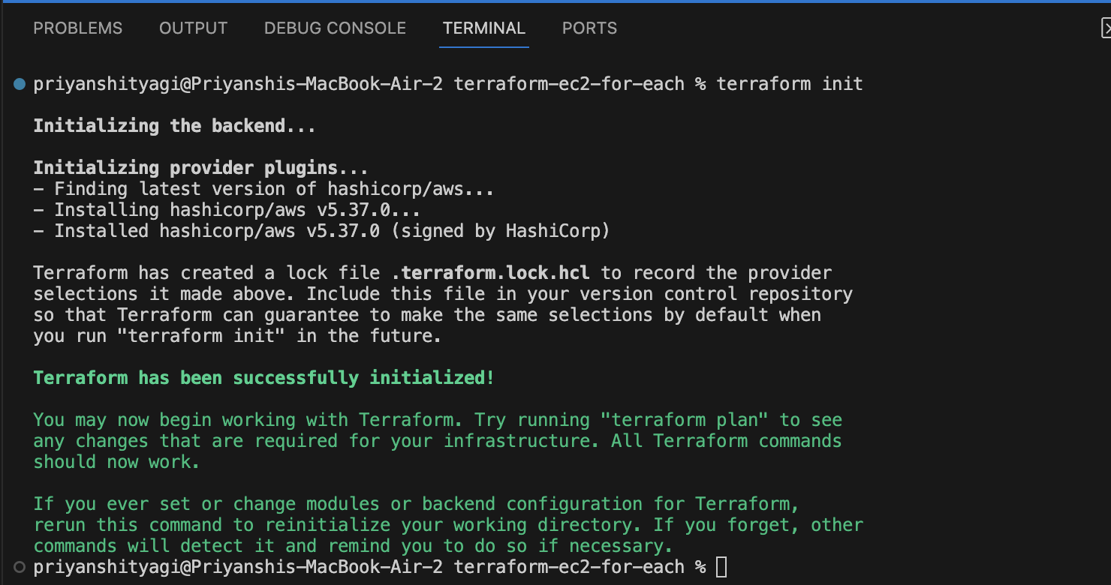
2. **Initialize and Apply:** 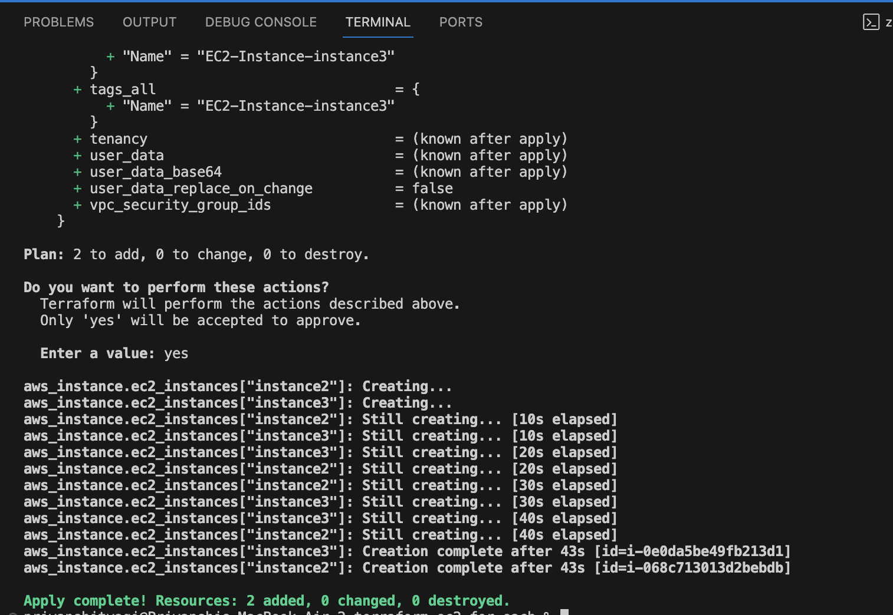

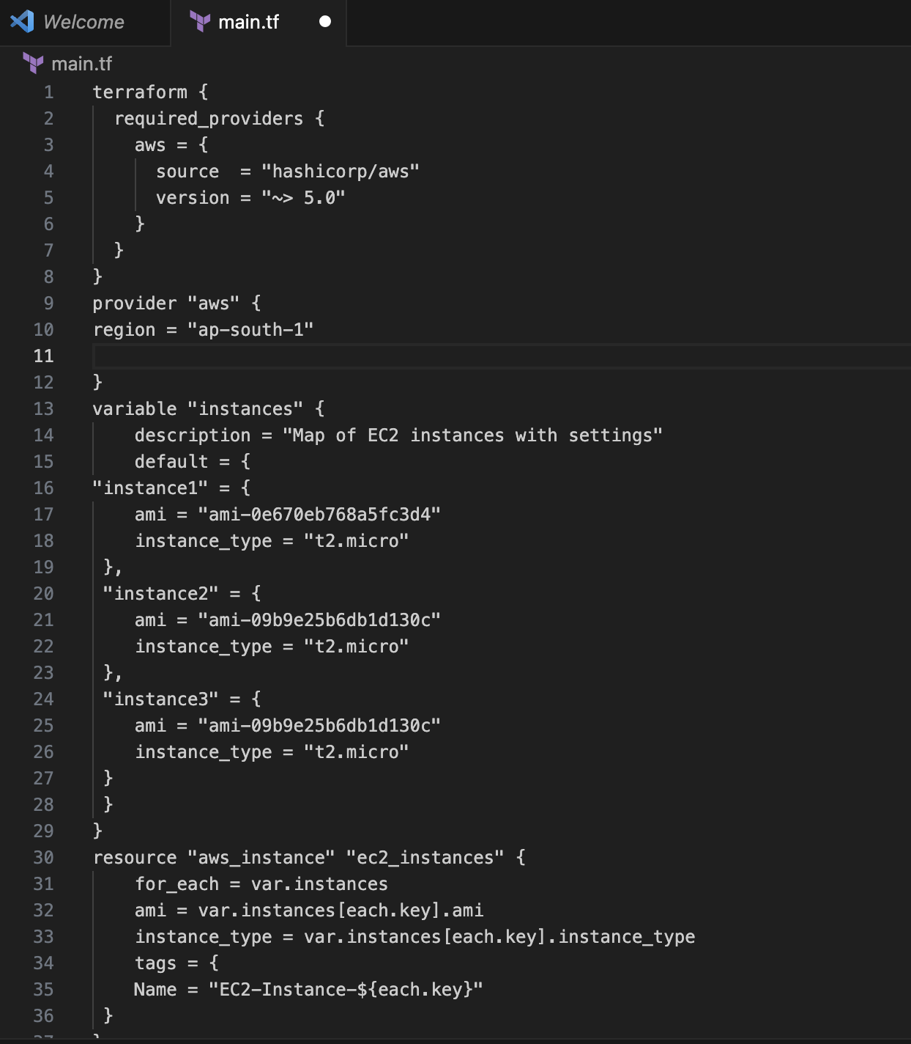

1. **Verify Instances in AWS Console:**

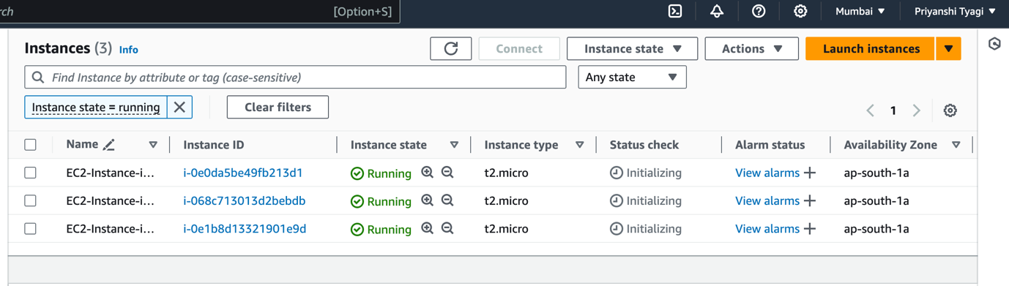

1. **Clean Up:**

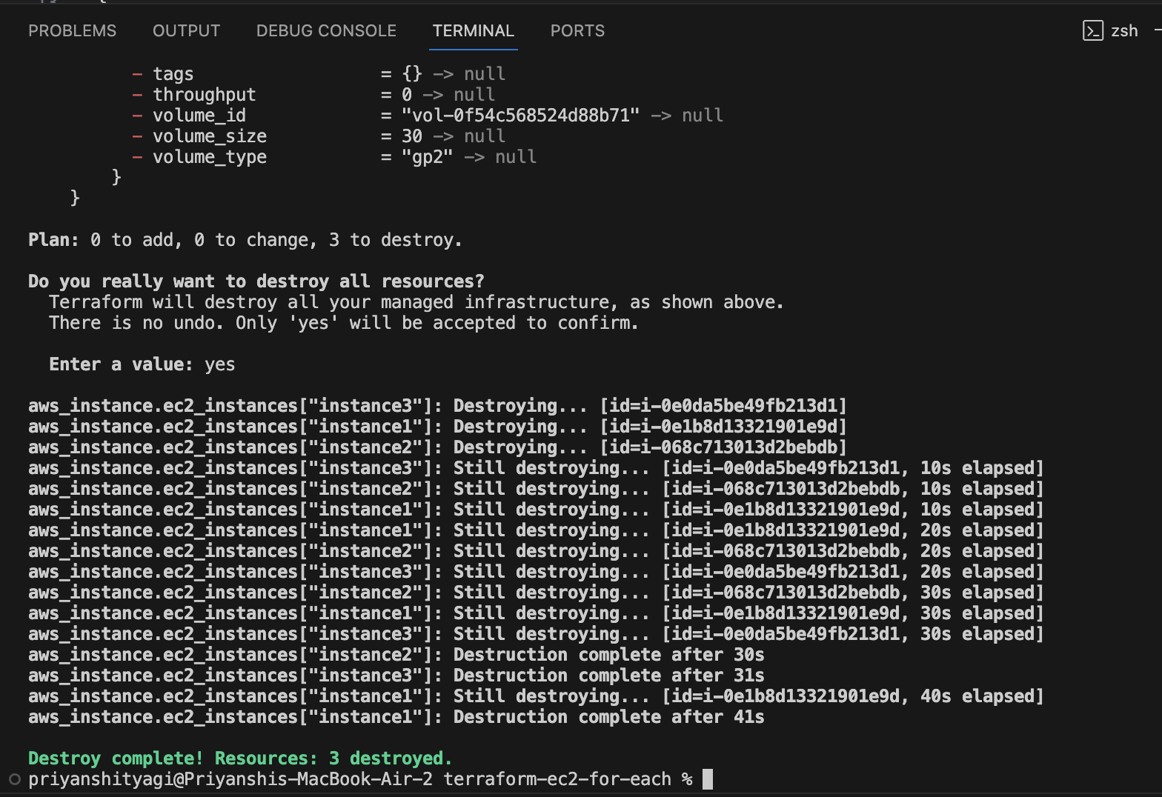

**Lab Exercise 10– Creating an AWS RDS Instance in**

**Terraform**

**Steps:**

**1. Create a Terraform Directory: **

**2. Create Terraform Configuration Files:**

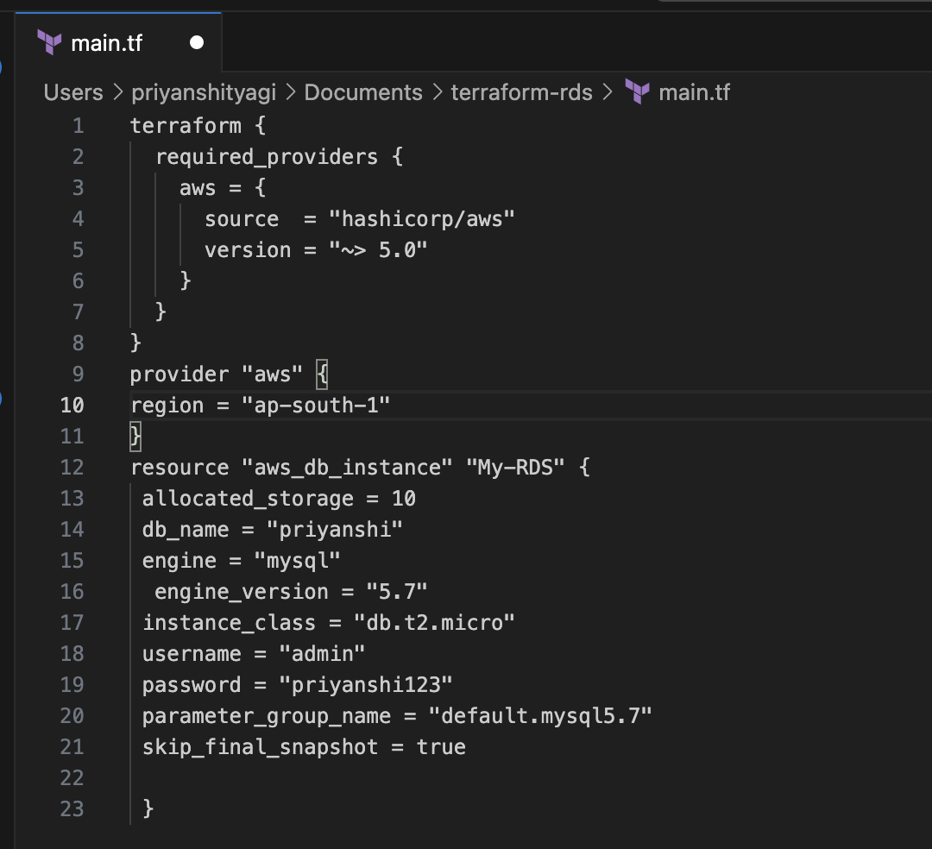

**3. Initialize and Apply:** 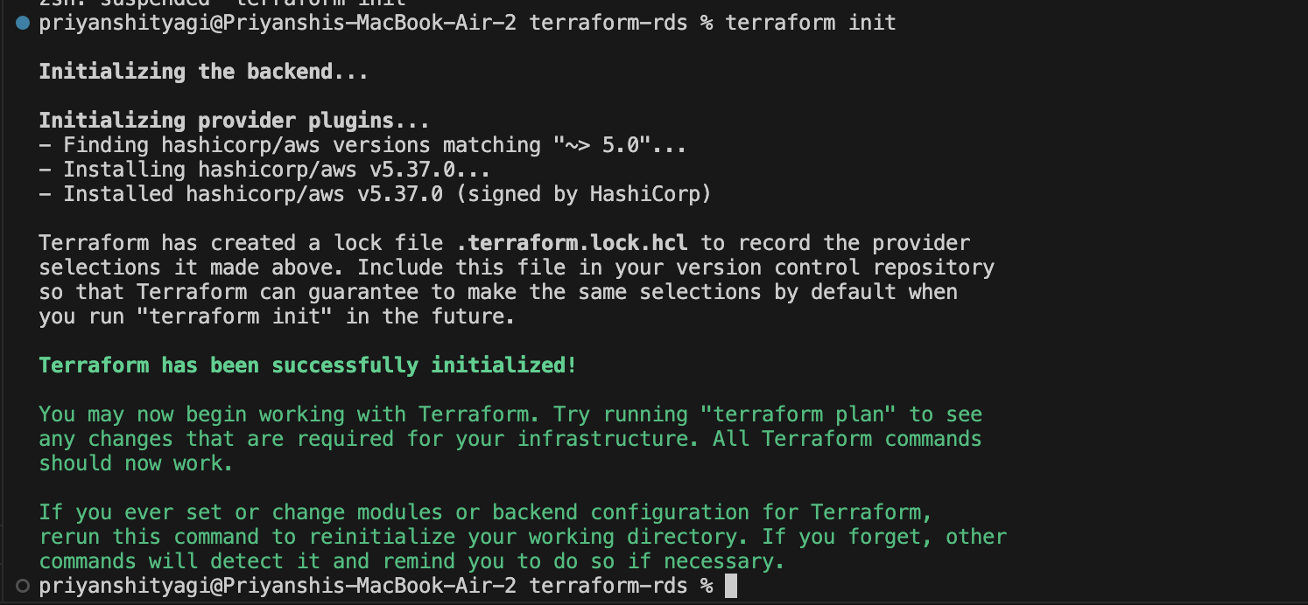

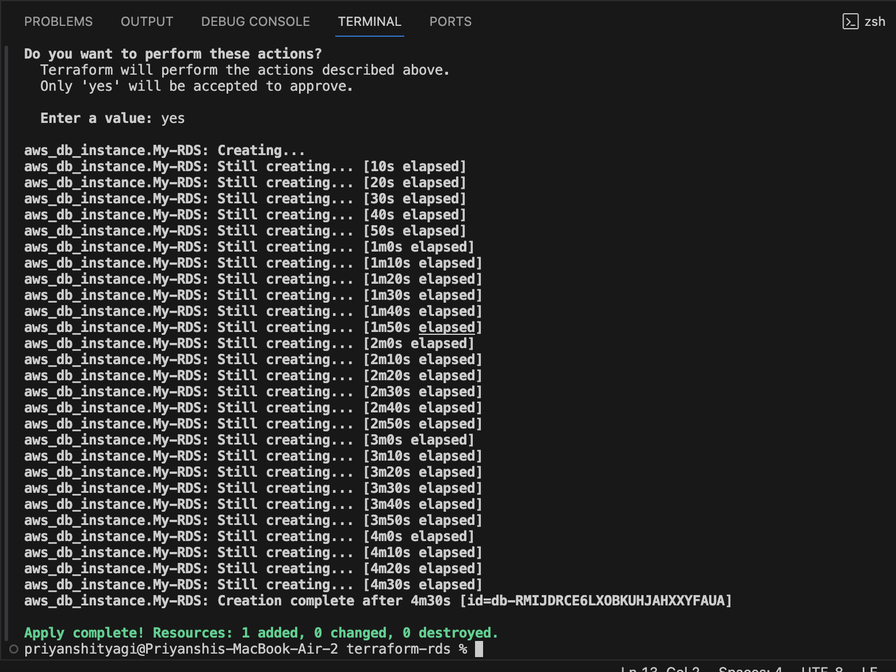

**4.Verify RDS Instance in AWS Console:**

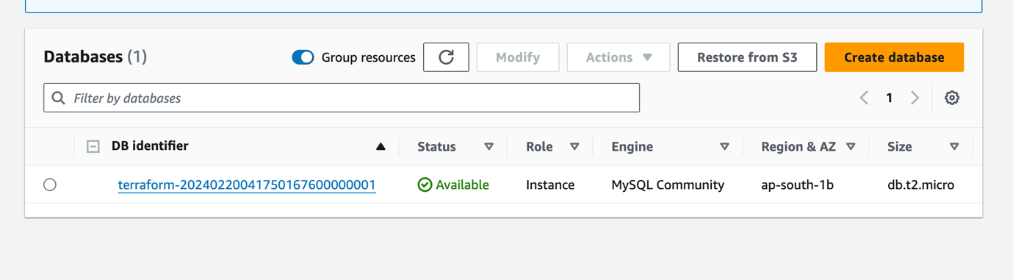

**5.Clean Up:**

